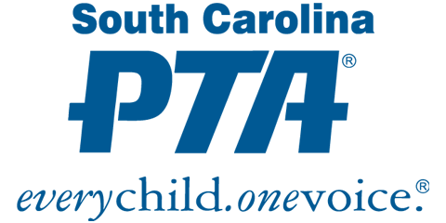

Update the red text for your specific PTA unit and consider changing the graphic above to your own

Name of PTA Unit
General Membership E-Meeting
Date (voting complete)

I. Nominating Slate 20__-20__
The 20__ Nominating Committee consisted of the following members: Names of Committee members. On date, all PTA members in Givebacks received a digital link that included the proposed slate of officers for the 20__- 20__ academic year as follows:
Position: Nominee
Position: Nominee
Position: Nominee
Members were asked to vote Yes/No to approve the slate with a deadline of date. The Nominating Chair/Committee verified total votes and that a quorum was established. Quorum for name of PTA unit was ###. This was calculated before the electronic vote and is ten (10) percent of the number of members at the time the vote was initiated.
With ### online votes received (### Yes/# No), the vote to approve the slate of officers passed/failed.

