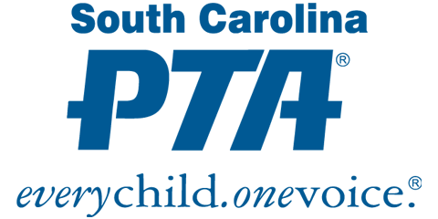

Update the red text for your specific PTA unit and consider changing the graphic above to your own

Name of PTA Unit
General Membership E-Meeting
Date (voting complete)

I. Proposed Budget 20__-20__
On date, all members in Givebacks received a digital link that included the proposed name of PTA unit budget for 20__- 20__.

Members were asked to vote Yes/No to approve the budget with a deadline of date. The President verified the total votes and that a quorum was established. Quorum for name of PTA unit is at least ### members from four different districts. With ### online votes received (### Yes/# No), the vote to approve the budget passed/failed.

Submitted by: Name
Secretary (or other Position)

Attach a copy of the budget and submit in Givebacks Compliance

