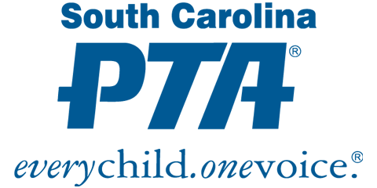

SAMPLE MEETING MINUTES FOR BYLAWS VOTING

Update the words in red for your specific PTA unit.
Complete the section that matches the process you used (Electronic, In-person, Hybrid), then delete the sections you did not need.

Name of Unit
General Membership Meeting
Date (voting complete)

ELECTRONIC VOTING
I. Proposed Bylaws
On date, all PTA members in Givebacks received an email detailing the proposed changes to the PTA Bylaws. They were asked to direct any questions to the PTA President or PTA Secretary prior to date.
On date, all PTA members in Givebacks received a digital link to vote on the proposed changes to the PTA Bylaws.
Members were asked to vote Yes/No to approve the Bylaws with a deadline of date. The PTA Secretary verified the total number of votes and that a quorum was established. Quorum for name of PTA unit is at least ### members. With ### Yes and ### No votes, the vote to approve the Bylaws passed/failed.

Submitted by: Name
Position

IN-PERSON VOTING
I. Proposed Bylaws
On date, all PTA members in Givebacks received an email detailing the proposed changes to the PTA Bylaws. They were asked to direct any questions to the PTA President or PTA Secretary prior to date.
On date, a general membership meeting was held for the purpose of approving the proposed changes to the PTA Bylaws.
Members were asked to vote by ballot (or by voice) Yes/No to approve the Bylaws. The Secretary verified that a quorum was established with ### PTA members present. Quorum for name of PTA unit is at least ### members. With ### Yes and ### No votes, the vote to approve the Bylaws passed/failed.

Submitted by: Name
Position

HYBRID VOTING
I. Proposed Bylaws
On date, all PTA members in Givebacks received an email detailing the proposed changes to the PTA Bylaws. They were asked to direct any questions to the PTA President or PTA Secretary prior to date.
On date, a general membership meeting was held for the purpose of approving the proposed changes to the PTA Bylaws.
Members were asked to vote by ballot (or by voice) Yes/No to approve the Bylaws. The Secretary verified that 48 PTA members were present. Quorum for name of PTA unit is at least ### members. With ### Yes and ### No votes, the vote was tallied and recorded.
On date, all PTA members in Givebacks received a digital link to vote for the proposed changes to the PTA Bylaws.
Members who were not present at the in-person meeting were asked to vote Yes/No to approve the Bylaws with a deadline of date. The PTA Secretary verified total votes and checked voters against the membership roster and meeting roster to ensure that only the votes of current PTA members who did not vote at the in-person meeting were counted. With ### Yes and # No online votes, the vote was tallied and recorded.
With a total of ### votes cast (### Yes/# No), the proposed Bylaws were approved/not approved.

Submitted by: Name
Position

